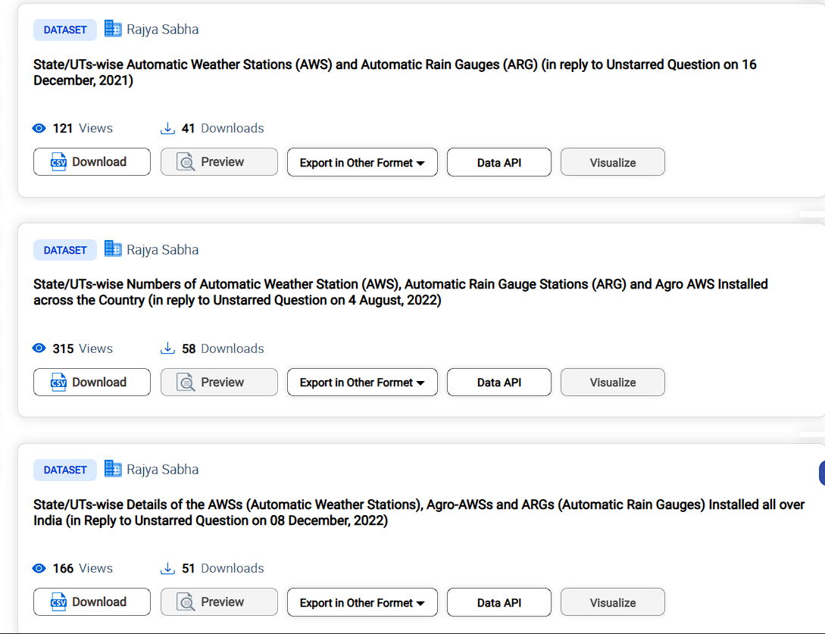

Excel links

REAL TIME AIR QUALITY INDEX

VEHICLE EMISSION DATA

ANNUAL SEASONAL TEMPERATURE

